A
Project Work Report
On
“Full Stack Hospital Management System using React and Java with Spring boot”
Submitted to
SRI VENKATESWARA COLLEGE OF ENGINEERING AND TECHNOLOGY (AUTOMOMOUS)
Affiliated to JNTUA, Anathapuramu
In partial fulfillment of the requirements for the award of the degree of
BACHELOR OF TECHNOLOGY
IN
INFORMATION TECHNOLOGY ( IT )
during the academic year 2025-2026
Submitted by
B.JAGADESHWAR REDDY 22781A1204 B.DONA PRAJWALIKA 22781A1205
C.SANDHYA 22781A1214
L.DIVYA SREE 22781A1257
M.SAI KISHORE 22781A1260

Under the esteemed guidance of
P.Nanda kumar , M.E,Phd Assisstant Professor
Department of Information Technology

SRI VENKATESWARA COLLEGE OF ENGINEERING AND TECHNOLOGY(AUTONOMOUS)
Affiliated to JNTUA, Anathapuramu-515002(A.P) & Approved by AICTE, New Delhi
Accredited by NAAC, Bengaluru & NBA, New Delhi
An ISO 9001:2000 Certified Institution
R.V.S. Nagar, Chittoor-517127(A.P), India
www.svcetedu.org

SRI VENKATESWARA COLLEGE OF ENGINEERING AND TECHNOLOGY
(AUTONOMOUS)
Affiliated to JNTUA, Anathapuramu-515002(A.P) & Approved by AICTE, New Delhi
Accredited by NAAC, Bengaluru & NBA, New Delhi
An ISO 9001:2000 Certified Institution
R.V.S. Nagar, Chittoor-517127(A.P), India
www.svcetedu.org

CERTIFICATE


This is to certify that, the project entitled, “Full Stack Hospital management System using React and Java with Spring boot ” is a bonafide work carried by the following students
B.JAGADESHWAR REDDY 22781A1204 B.DONA PRAJWALIKA 22781A1205
C.SANDHYA 22781A1214
L.DIVYA SREE 22781A1257
M.SAI KISHORE 22781A1260

in partial fulfillment of the requirement for the award of the degree BACHELOR OF TECHNOLOGY in INFORMATION TECHNOLOGY during the academic year 2025-2026

SIGNATURE OF THE GUIDE SIGNATURE OF THE HOD
Mr.P.Nanda kumar, M.E, Ph.D. Dr.J.Velmurgan, Ph.D.
Assistant Professor HOD & Professor
Department of Information Technogoly. Department of Information Technology.
SVCET(AUTONOMOUS) SVCET(AUTONOMOUS)

INTERNAL EXAMINER EXTERNAL EXAMINIER

Viva-Voce Conducted on

SRI VENKATESWARA COLLEGE OF ENGINEERING AND TECHNOLOGY
(AUTONOMOUS)
Affiliated to JNTUA, Anathapuramu-515002(A.P) & Approved by AICTE, New Delhi
Accredited by NAAC, Bengaluru & NBA, New Delhi
An ISO 9001:2000 Certified Institution
R.V.S. Nagar, Chittoor-517127(A.P), India
www.svcetedu.org

Department of Information Technology

DECLARATION

We
B.JAGADESHWAR REDDY 22781A1204 B.DONA PRAJWALIKA 22781A1205
C.SANDHYA 22781A1214
L.DIVYA SREE 22781A1257
M.SAI KISHORE 22781A1260

hereby declare that the Project Report entitled " Full Stack Hospital Management System using React and Java with Spring boot" under the guidance of Mr.P.Nanda Kumar, M.E,Ph.d, Sri Venkateswara College of Engineering & Technology (Autonomous), Chittoor is submitted in partial fulfillment of the requirements for the award of the degree of BACHELOR OF TECHNOLOGY in INFORMATION TECHNOLOGY.
This is a record of bonafied work carried out by us and the results embodied in this project have not been reproduced or copied from any source. The results embodied in this project report have not been submitted to any other university or institution for the award of any other degree or diploma.

ACKNOWLEDGEMENT

A Grateful thanks to Dr.R.Venkataswamy, Chairman, Sri Venkateswara College of Engineering and Technology for providing education in their esteemed institution.
We, wish to record our deep sense of gratitude and profound thanks to our beloved Vice Chairman, Sri. R.V. Srinivas for his valuable support throughout the course.

We, express our sincere thanks to Dr. M. Mohan Babu, our beloved principal for his encouragement and suggestions during the course of study.

We, wish to convey our gratitude and express our sincere thanks to our Mr.P.Nanda Kumar, M.E, Ph.D, Assisstant Professor, IT , for giving us his inspiring guidance in undertaking our project report.

We express our sincere thanks to the Project Guide Dr.J.Velmurugan, Ph.D, Professor & Head of the Department, IT, for his keen interest, stimulating guidance, encouragement with our work during all stages, to bring this project into fruition.

We, wish to convey our gratitude and express our sincere thanks to all Project Review Committee members for their support and cooperation rendered for successful submission of our project work. Finally, we would like to express our sincere thanks to all teaching, non-teaching faculty members, our parents, and friends and for all those who have supported us to complete the project work successfully.

B.JAGADESHWAR REDDY 22781A1204 B.DONA PRAJWALIKA 22781A1205
C.SANDHYA 22781A1214
L.DIVYA SREE 22781A1257
M.SAI KISHORE 22781A1260


SRI VENKATESWARA COLLEGE OF ENGINEERING AND TECHNOLOGY
(AUTONOMOUS)
R.V.S. NAGAR, CHITTOOR-517 127, ANDHRA PRADESH
DEPARTMENT OF INFORMATION TECHNOLOGY

Vision and Mission of the Department under R20 Regulations

VISION

To provide leading Technologies in Information Technology & Computer Science fields to our

graduates to be globally recognized as innovative computing professionals.

MISSION
- The Department of Information Technology is dedicated to produce Software Engineers with basic knowledge in math develop problem solving skills necessary for the career advancement in Computer Science / IT & allied disciplines, and practice.
- Produce engineers with a strong practical and theoretical exposure in the relevant disciplines, who are able to contribute to society through innovation enterprise and leadership.
- Nurture engineer with a global outlook and to provide technological leadership through necessary technical tools.
- Produce engineers with teamwork, communication and interpersonal skill.

SRI VENKATESWARA COLLEGE OF ENGINEERING AND TECHNOLOGY
(AUTONOMOUS)
R.V.S. NAGAR, CHITTOOR-517 127, ANDHRA PRADESH DEPARTMENT OF INFORMATION TECHNOLOGY

Program Educational Objectives (PEOs) under R20 Regulations

Program Educational Objectives (PEOs):
PEO1: To Educate and train students in professional career by acquiring knowledge in scientific,mathematics and computing and engineering principles.

PEO2: Apply, Analysis, Design, Optimization and Implementation skills in order to formulate and solve Computer Science,Engineering and Multidisciplinary problems.
PEO3: Use their skills in ethical & professional manner to raise the satisfaction level of stakeholders and to take up higher studies, research & development and other creative efforts in science & technology.

SRI VENKATESWARA COLLEGE OF ENGINEERING AND TECHNOLOGY
(AUTONOMOUS)
R.V.S. NAGAR, CHITTOOR-517 127, ANDHRA PRADESH
DEPARTMENT OF INFORMATION TECHNOLOGY

Program Specific Outcomes (PSOs) under R20 Regulations

Program Specific Outcomes (PSOs):
PSO1: Analyze and recommend the appropriate IT infrastructure required for the implementation of a project.
PSO2: Design, develop and test the software system for world-wide network of computers to provide solutions to real word problems.

SRI VENKATESWARA COLLEGE OF ENGINEERING AND TECHNOLOGY
(AUTONOMOUS)
R.V.S. NAGAR, CHITTOOR-517 127, ANDHRA PRADESH
DEPARTMENT OF INFORMATION TECHNOLOGY
PROGRAM OUTCOMES

On successful completion of the Program, the graduates of B. Tech. IT Program will be able to:
1. Engineering knowledge: Apply the knowledge of mathematics, science, engineering fundamentals, and an engineering specialization to the solution of complex engineering problems.
2. Problem analysis: Identify, formulate, review research literature, and analyze complex engineering problems reaching substantiated conclusions using first principles of mathematics, natural sciences, and engineering sciences
3. Design / Development of solutions: Design solutions for complex engineering problems and design system components or processes that meet the specified needs with appropriate consideration for the public health and safety, and the cultural, societal, and environmental considerations.
4. Conduct investigations of complex problems: Use research-based knowledge and research methods including design of experiments, analysis and interpretation of data, and synthesis of the information to provide valid conclusions..
5. Conduct investigations of complex problems: Use research-based knowledge and research methods including design of experiments, analysis and interpretation of data, and synthesis of the information to provide valid conclusions.
6. The engineer and society: Apply reasoning informed by the contextual knowledge to assess societal, health, safety, legal and cultural issues and the consequent responsibilities relevant to the professional engineering practice.
7. Environment and sustainability: Understand the impact of the professional engineering solutions in societal and environmental contexts, and demonstrate the knowledge of, and need for sustainable development.
8. Ethics: Apply ethical principles and commit to professional ethics and responsibilities and norms of the engineering practice.
9. Individual and team work: Function effectively as an individual, and as a member or leader in diverse teams, and in multidisciplinary settings.
10. Communication: Communicate effectively on complex engineering activities with the engineering community and with society at large, such as, being able to comprehend and write effective reports and design documentation, make effective presentations, and give and receive clear instructions.
11. Project management and finance: Demonstrate knowledge and understanding of the engineering and management principles and apply these to one’s own work, as a member and leader in a team, to manage projects and in multidisciplinary environments.
12. Life-long learning: Recognize the need for, and have the preparation and ability to.

SRI VENKATESWARA COLLEGE OF ENGINEERING AND TECHNOLOGY

(Autonomous)

IV B.Tech II Semester IT

20AIT33: PROJECT WORK, SEMINAR AND INTERNSHIP IN INDUSTRY
 |  |  |  |  |  | L | T | P | C
 |  |  |  |  |  | - | - | - | 12
COURSE OUTCOMES:

After successful completion of this course, the students will be able to:

1. Analyze the functional requirements of a Hospital Management System and identify key modules such as patient management, appointment scheduling, billing, and staff management.
2. Design an efficient and user-friendly system architecture using appropriate software engineering principles and database design techniques..
3. Perform individually or in a team besides communicating effectively in written, oral and graphical forms on computer engineering systems or processes.
4. Develop a full-stack Hospital Management System using modern technologies (such as Java, React, databases, and APIs) to automate hospital operations.
5. Demonstrate teamwork, documentation skills, and problem-solving abilities by completing the project following industry-standard practices.

ABSTRACT

The Hospital Management System (HMS) is a comprehensive software solution designed to automate and streamline the day-to-day operations of hospitals and healthcare institutions. In traditional hospital environments, most administrative and clinical processes such as patient registration, appointment scheduling, medical record maintenance, billing, and staff coordination are handled manually or through disconnected systems. These approaches often lead to data redundancy, human errors, delays in service delivery, inefficient resource utilization, and difficulties in maintaining accurate patient records. The proposed Hospital Management System aims to overcome these challenges by providing an integrated, centralized, and user-friendly digital platform that enhances operational efficiency and improves the overall quality of healthcare services.
This project focuses on developing a robust and scalable HMS that manages all major hospital activities through well-defined modules. The system includes modules for patient management, doctor management, appointment scheduling, billing and payments, laboratory reports, and administrative control. Each module is designed to perform specific functions while maintaining seamless data flow across the system. Patient information such as personal details, medical history, consultation records, and test results is securely stored in a centralized database, enabling quick access and efficient retrieval. This ensures better continuity of care and reduces the risk of data loss or inconsistency.
The Hospital Management System is developed using modern full-stack technologies that support both frontend and backend operations. The frontend provides an intuitive and responsive user interface that allows patients, doctors, and administrative staff to interact with the system easily. The backend handles business logic, data processing, and secure communication between different system components. Role-based access control is implemented to ensure that sensitive information is accessed only by authorized users, thereby maintaining confidentiality and compliance with data protection standards.
One of the key features of the system is its appointment management functionality, which enables patients to book appointments online based on doctor availability. This reduces waiting time, avoids scheduling conflicts, and improves patient satisfaction. Doctors can view their schedules, access patient records, and update treatment details efficiently. The billing module automates invoice generation, payment tracking, and report generation, reducing manual effort and minimizing accounting errors. Administrative users can monitor hospital activities, manage staff records, and generate analytical reports for decision-making.

TABLE OF CONTENT:

SL.NO | CONTENT | PAGE NO
 | ABSTRACT | i
1 | INTRODUCTION  1.1 PROBLEM STATEMENT | 01
2 | LITERATURE SURVEY | 03
3 | DATA COLLECTION | 05
4 | SYSTEM STUDY  4.1 EXISTING SYSTEM  4.2 PROPOSED SYSTEM | 06
5 | METHODOLOGY  5.1 ENHANCEMENTS | 09
6 | IMPLEMENTATION  6.1 DATA FLOW | 11
7 | SYSTEM SPECIFICATIONS  7.1 HARDWARE REQUIRMENTS  7.2 SOFTWARE REQUIRMENTS  7.3 EXECUTION OF FRONT-END | 18
8 | EXPERIMENTAL SETUP & RESULTS  8.1 EXPERIMENTAL SETUP  8.2 RESULTS | 21
9 | CODING  9.1 MODEL TRAINING CODE | 23
10 | EXECUTION SCREENSHOTS | 32
11 | LIMITATIONS | 36
12 | FUTURE SCOPE | 37
13 | APPLICATION | 38
14 | SYSTEM TESTING | 39
15 | CONCLUSION | 42
 | REFERENCES | 43

INTRODUCTION

The rapid growth of the healthcare sector has increased the demand for efficient management of hospital operations and accurate handling of medical information. Hospitals today are required to manage large volumes of data related to patients, doctors, staff, appointments, treatments, laboratory reports, and financial transactions. In many healthcare institutions, these activities are still handled using manual procedures or partially computerized systems, which often results in inefficiency, data inconsistency, and delays in service delivery. As a result, there is a strong need for an integrated digital solution that can manage hospital activities in a systematic and reliable manner.
A Hospital Management System (HMS) is a software-based solution designed to automate and coordinate the core administrative and clinical functions of a hospital. The primary objective of such a system is to improve the quality of healthcare services by reducing manual workload, minimizing errors, and ensuring timely access to accurate information. By centralizing hospital data into a single platform, the system enables smooth communication among different departments, including reception, consultation, laboratory, billing, and administration. This integration plays a crucial role in improving operational efficiency and enhancing patient care.
The traditional hospital management process involves maintaining physical records, handwritten prescriptions, and manual appointment scheduling. These methods are time-consuming and make it difficult to track patient history, manage doctor availability, and generate accurate reports. Additionally, manual record keeping increases the risk of data loss, duplication, and unauthorized access. In contrast, a computerized Hospital Management System stores data in a secure database, allowing authorized users to access and update information quickly. This not only saves time but also improves data reliability and transparency.
With advancements in information technology, modern Hospital Management Systems are developed using full-stack architectures that support scalability, security, and user-friendly interfaces. The system provides role-based access to different users such as patients, doctors, and administrators, ensuring that each user interacts only with the relevant features. Patients can register, book appointments, and view their medical records, while doctors can manage consultations, review patient histories, and update treatment details. Administrative staff can oversee hospital operations, manage staff details, and generate reports for effective decision-making.
Another significant advantage of a Hospital Management System is its ability to improve patient experience and service quality. Automated appointment scheduling reduces waiting time and prevents overcrowding. Digital medical records ensure continuity of care by allowing healthcare professionals to access complete patient histories during consultations. Automated billing and payment processes simplify financial transactions and reduce accounting errors. These features collectively contribute to a more organized and patient-centered healthcare environment.
Security and data privacy are critical concerns in healthcare systems. The Hospital Management System addresses these concerns by implementing authentication mechanisms, authorization controls, and secure data storage techniques. Regular backups and validation checks further ensure system reliability and data integrity. Moreover, the modular design of the system allows future enhancements such as integration with laboratory systems, pharmacy management, insurance services, and mobile applications, making it adaptable to the evolving needs of the healthcare industry.
In summary, the Hospital Management System represents a significant step toward the digital transformation of healthcare administration. By automating hospital workflows and providing accurate, real-time information, the system enhances efficiency, reduces operational complexity, and supports better healthcare outcomes. This project highlights the practical application of software engineering and full-stack development concepts in addressing real-world challenges in hospital management.
1.1 Problem Statement
- Hospitals are complex organizations that require efficient coordination of multiple departments, resources, and personnel to deliver quality healthcare services. In many healthcare institutions, hospital operations such as patient registration, appointment scheduling, medical record maintenance, billing, laboratory reporting, and staff management are still handled through manual processes or fragmented software systems. These traditional approaches create significant challenges in managing hospital workflows effectively and meeting the growing expectations of patients and healthcare providers.
- One of the major problems faced by hospitals is the inefficient handling of patient information. Manual record keeping often results in incomplete, inaccurate, or duplicated data, making it difficult for doctors to access a patient’s complete medical history at the time of consultation. This lack of timely and reliable information can lead to delays in diagnosis, inappropriate treatment decisions, and reduced quality of care. Additionally, paper-based records are vulnerable to physical damage, loss, and unauthorized access, raising serious concerns about data security and patient confidentiality.
- Appointment management is another critical issue in traditional hospital systems. Appointments are often scheduled manually without real-time visibility of doctor availability, leading to scheduling conflicts, long waiting times, and patient dissatisfaction. Overcrowding in hospitals further increases the burden on staff and reduces the efficiency of healthcare delivery. Without an automated system, it becomes difficult to optimize schedules, manage emergency cases effectively, and ensure fair distribution of workload among doctors.
- Billing and financial management processes also pose major challenges when handled manually. Generating bills, tracking payments, and maintaining financial records require significant time and effort, and are prone to calculation errors. These inaccuracies can result in revenue loss for hospitals and confusion for patients. Moreover, the absence of integrated reporting tools makes it difficult for hospital administrators to monitor financial performance and make informed decisions.
- Another important problem is the lack of coordination among different hospital departments. In many cases, laboratory reports, pharmacy records, and treatment details are maintained separately, causing delays in information flow. This fragmented approach reduces operational efficiency and increases the risk of miscommunication. Staff management, including tracking duty schedules, roles.

LITERATURE REVIEW

The literature review presents an overview of existing research and studies related to Hospital Management Systems. It highlights various approaches, technologies, and challenges discussed by researchers in developing efficient healthcare management solutions. This review helps in understanding current trends, identifying limitations in existing systems, and justifying the need for the proposed solution.

a) AUTHORS:
R. Kumar, S. Verma, and P. Singh
ABSTRACT:
The authors proposed a computerized Hospital Management System aimed at reducing manual effort in hospital administration. Their study focuses on automating patient registration, appointment scheduling, and medical record management. The system emphasizes centralized data storage to avoid duplication and inconsistency of patient information. The researchers highlighted that traditional paper-based systems are inefficient and prone to errors, especially in large hospitals with high patient flow. The proposed solution improves data accuracy and enables faster access to patient records for doctors and staff. However, the study provides limited discussion on security mechanisms and scalability, which are critical for modern healthcare environments.

b) AUTHORS:
A. Sharma and M. Gupta
ABSTRACT:
This study presents a web-based Hospital Management System designed to enhance communication between patients, doctors, and administrative staff. The authors focused on online appointment booking, doctor scheduling, and automated billing processes. The system uses a client-server architecture to ensure real-time data access and smooth coordination among hospital departments. The research highlights how automation reduces patient waiting time and improves service quality. Although the system improves operational efficiency, the authors note challenges related to data privacy and the need for stronger authentication techniques to protect sensitive medical information.

c) AUTHORS:
L. Wang, Y. Chen, and H. Liu
ABSTRACT:
The authors explored the use of database-driven Hospital Management Systems to improve data handling and reporting in healthcare institutions. Their research emphasizes structured database design for managing patient records, laboratory reports, and financial transactions. The study demonstrates that a well-designed database improves data integrity and supports efficient report generation for hospital administrators. The authors also discussed the importance of backup and recovery mechanisms to prevent data loss. However, the system described lacks user-friendly interfaces and does not fully address integration with modern frontend technologies.

d) AUTHORS:
S. Patel and N. Desai
ABSTRACT:
This paper focuses on the role of role-based access control in Hospital Management Systems. The authors proposed a system where different users such as patients, doctors, nurses, and administrators have controlled access based on their responsibilities. The study highlights that improper access control can lead to data misuse and privacy violations. By implementing authentication and authorization mechanisms, the system ensures confidentiality and secure handling of patient data. While the security model is effective, the authors mention that the system requires further enhancements to support scalability and integration with external healthcare services such as laboratories and pharmacies.

e) AUTHORS:
J. Rao and K. Mehta
ABSTRACT:
The authors presented a modular Hospital Management System designed for flexibility and future expansion. Their research focuses on dividing the system into independent modules such as patient management, appointment management, billing, and reporting. This modular approach allows easy maintenance and integration of new features. The study highlights the importance of using modern software engineering practices to improve system reliability and performance. Although the system supports efficient hospital operations, the authors suggest incorporating advanced technologies such as cloud computing and analytics to further enhance decision-making and system scalability.
- DATA COLLECTION
Data collection is a crucial phase in the development of the Hospital Management System, as the accuracy and reliability of the system largely depend on the quality of data gathered during this stage. The purpose of data collection in this project is to identify the essential information required to support hospital operations and to understand how data flows between different departments within a healthcare institution. Proper data collection ensures that the system meets functional requirements and supports efficient decision-making.
The primary data collected for the Hospital Management System includes patient information such as personal details, contact information, demographic data, medical history, and treatment records. This data is essential for identifying patients uniquely and maintaining continuity of care. Collecting structured patient data allows doctors to access previous consultation details, diagnoses, and prescribed medications, which helps in providing accurate and timely medical services.
Doctor and staff-related data is another important component of the data collection process. This includes information such as staff identification details, roles, specializations, duty schedules, and availability. Collecting this data enables efficient appointment scheduling, workload distribution, and staff management. It also helps hospital administrators monitor staff performance and allocate resources effectively.
Appointment-related data is collected to manage patient visits and consultations efficiently. This includes appointment dates, time slots, doctor assignments, and appointment status. Accurate appointment data helps reduce scheduling conflicts, minimize patient waiting time, and improve overall hospital workflow. Emergency and follow-up appointment details are also considered to ensure flexible scheduling and better patient care.
Financial and billing data is collected to support hospital revenue management. This data includes consultation charges, treatment costs, laboratory fees, payment details, and billing history. Proper collection and organization of financial data ensure transparency in billing processes and help reduce errors in invoice generation. It also assists hospital management in generating financial reports and analyzing revenue trends.
Laboratory and diagnostic data such as test requests, test results, and report dates are collected to support clinical decision-making. Integrating this data with patient records ensures that doctors can access diagnostic information quickly and accurately. This reduces delays in treatment and improves coordination between clinical and laboratory departments.
The data for this project is collected through multiple sources, including direct observation of hospital workflows, interaction with healthcare staff, review of hospital forms and records, and analysis of existing hospital management software. These methods help in understanding real-world requirements and ensure that the system design aligns with actual hospital operations.
In conclusion, the data collection process lays the foundation for an effective Hospital Management System. By carefully identifying and organizing patient, staff, appointment, billing, and laboratory data, the system ensures accurate information management, improved operational efficiency, and enhanced healthcare service delivery.

4 SYSTEM STUDY

4.1 Existing System

The existing system in many hospitals primarily relies on manual processes and partially computerized methods to manage daily operations. Patient registration, appointment scheduling, medical record maintenance, billing, and reporting are often handled using paper-based files or independent software applications. These systems lack proper integration, which makes hospital management complex and inefficient, especially when dealing with a large number of patients.

In the current system, patient details are usually recorded manually in registers or basic computer files. Medical histories, prescriptions, and laboratory reports are stored separately, making it difficult to retrieve complete patient information during consultations. This fragmented storage increases the chances of data duplication, inconsistency, and misplacement of important records. Doctors often spend additional time searching for previous records, which affects the quality and speed of healthcare services.

Appointment scheduling in the existing system is generally performed manually at the reception desk. This approach does not provide real-time visibility of doctor availability, leading to scheduling conflicts, long waiting times, and overcrowding. Emergency cases are difficult to manage efficiently due to the absence of automated scheduling and prioritization mechanisms. Patients may experience delays and inconvenience due to improper appointment coordination.

Billing and financial management in the exis

.

Disadvantages of Existing System
- The existing system relies heavily on manual and paper-based processes, which are time-consuming and inefficient.
- Patient records are not stored in a centralized manner, leading to data duplication and inconsistency.
- Retrieving patient history and medical records takes more time, especially during emergency situations.
- Manual appointment scheduling causes long waiting times and frequent scheduling conflicts.
- There is no real-time visibility of doctor availability, resulting in poor workload management.
- Billing and payment processes are prone to calculation errors due to manual handling.
- Financial data is not properly synchronized with patient treatment records, making auditing difficult.
- Sensitive patient information lacks adequate security and is vulnerable to unauthorized access.
- There are no reliable data backup and recovery mechanisms, increasing the risk of permanent data loss.
- Communication between departments such as laboratory, pharmacy, and administration is slow and inefficient.
- Staff management and duty scheduling are difficult to track and manage effectively.
- The system does not support scalability, making it unsuitable for hospitals with growing patient volumes.

Proposed System

The proposed system is a fully computerized and integrated Hospital Management System designed to overcome the limitations of the existing manual and fragmented approaches. This system aims to automate hospital operations and provide a centralized platform for managing patient information, appointments, medical records, billing, and administrative activities. By integrating all hospital functions into a single system, the proposed solution improves efficiency, accuracy, and overall quality of healthcare services.
In the proposed system, all hospital data is stored in a centralized and secure database. Patient information, including registration details, medical history, diagnostic reports, and treatment records, is maintained digitally and can be accessed quickly by authorized users. This centralized data management ensures consistency, eliminates data redundancy, and enables accurate record keeping. Doctors can review complete patient histories during consultations, leading to better diagnosis and treatment decisions.
The system introduces an automated appointment management module that allows patients to book appointments based on real-time doctor availability. This feature reduces patient waiting time, prevents scheduling conflicts, and ensures better utilization of medical resources. Doctors can manage their schedules efficiently, while administrative staff can monitor appointments and handle emergency cases more effectively.
The proposed system also automates billing and financial processes. Bills are generated automatically based on consultations, treatments, laboratory tests, and other services. This reduces calculation errors and ensures transparency in financial transactions. The system supports payment tracking and report generation, enabling hospital management to analyze financial performance and make informed decisions.
Role-based access control is a key feature of the proposed system. Different users such as patients, doctors, nurses, and administrators are granted access according to their roles and responsibilities. This ensures data security and protects sensitive medical information from unauthorized access. Authentication mechanisms and regular data backups further enhance system reliability and safety.

4.2.1 Advantages
- The proposed system provides centralized storage of hospital data, ensuring consistency and easy access to information.
- Automated patient registration and record management reduce manual effort and save time.
- Real-time appointment scheduling minimizes waiting time and avoids scheduling conflicts.
- Doctors can access complete patient medical histories instantly, improving diagnosis accuracy.
- Automated billing and payment processing reduce calculation errors and improve financial transparency.
- Role-based access control ensures that sensitive data is accessed only by authorized users.
- The system improves coordination between departments such as laboratory, pharmacy, and administration.
- Digital records reduce the risk of data loss and eliminate dependency on paper-based files.
- Built-in reporting features support hospital management in monitoring operations and performance.
- The system enhances data security through authentication, authorization, and regular backups.
- Modular system design allows easy maintenance and future expansion.
- Overall hospital efficiency and patient satisfaction are significantly improved.

METHODOLOGY
The methodology describes the systematic approach followed in the design and development of the Hospital Management System. This project adopts a structured and modular development process to ensure reliability, scalability, and ease of maintenance. Each phase of the methodology is carefully planned to address functional requirements and deliver an efficient healthcare management solution.
The first phase involves requirement analysis, where detailed information is gathered from hospital workflows, existing documentation, and user interactions. The functional requirements such as patient registration, appointment scheduling, medical record management, billing, and reporting are identified. Non-functional requirements including security, performance, and usability are also considered to ensure the system meets real-world healthcare standards.
In the design phase, the system architecture is planned using a layered approach that separates the user interface, business logic, and data access layers. Database design is carried out by identifying entities, attributes, and relationships to support structured and efficient data storage. User interface designs are created to ensure ease of use for patients, doctors, and administrators. Emphasis is placed on simplicity and accessibility to reduce user learning time.
The development phase focuses on implementing the system modules using full-stack technologies. Each module is developed independently following coding standards and best practices. The backend handles business logic, data processing, and secure communication with the database, while the frontend provides interactive and responsive user interfaces. Role-based authentication and authorization mechanisms are implemented during this phase to ensure data security.
Testing is conducted to verify the correctness and reliability of the system. Unit testing is performed on individual modules to identify and fix errors at an early stage. Integration testing ensures that different modules work together smoothly, and system testing validates overall functionality. Testing also includes validating data accuracy, user access control, and system performance under normal usage conditions.
After successful testing, the system is deployed in a controlled environment. Deployment involves configuring the server, database, and application components. User training and documentation are provided to ensure smooth adoption of the system. Feedback from users is collected to identify areas for improvement and to refine system functionality.
In summary, the methodology ensures a disciplined approach to developing the Hospital Management System. By following well-defined phases from requirement analysis to deployment, the project achieves a reliable, secure, and efficient system that addresses the challenges of hospital administration and improves healthcare service delivery.

5.1 Enhancements
The Hospital Management System is designed with flexibility to support future enhancements and technological advancements. Although the current system effectively automates core hospital operations, several improvements can be incorporated to further enhance system performance, usability, and healthcare service quality. These enhancements aim to extend system functionality and adapt it to the evolving needs of modern healthcare institutions.
One significant enhancement is the integration of mobile applications for patients and doctors. A mobile-based interface would allow patients to book appointments, receive notifications, and access medical reports through smartphones. Doctors could use mobile access to review patient records and update treatment details remotely, improving responsiveness and continuity of care.
Another important enhancement is the inclusion of advanced analytics and reporting features. By analyzing historical patient and treatment data, the system can generate insights related to disease trends, resource utilization, and hospital performance. These analytical tools would support hospital administrators in strategic planning and decision-making.
The system can also be enhanced by integrating pharmacy and inventory management modules. This would allow real-time tracking of medicine stock levels, automated alerts for low inventory, and better coordination between doctors and pharmacists. Such integration would reduce medication delays and prevent stock shortages.
Cloud-based deployment is another potential enhancement. Hosting the system on cloud platforms would improve scalability, availability, and data accessibility. Cloud integration also supports automated backups, disaster recovery, and easier system maintenance, making the system more reliable and cost-effective.
Security enhancements can further strengthen data protection. Implementing advanced authentication methods such as multi-factor authentication and encryption techniques would improve patient data confidentiality. Regular security audits and compliance with healthcare data standards would also enhance trust in the system.
Artificial Intelligence (AI) and Machine Learning (ML) technologies can be incorporated to support predictive healthcare services. These technologies could assist in disease prediction, patient risk assessment, and appointment optimization. AI-driven chatbots could also be introduced to handle basic patient queries and appointment assistance.
In conclusion, these enhancements provide a roadmap for future development of the Hospital Management System. By incorporating mobile access, analytics, cloud services, enhanced security, and intelligent technologies, the system can evolve into a more powerful and adaptable healthcare management platform.

IMPLEMENTATION

The implementation phase focuses on developing a functional Hospital Management System by transforming system design into executable modules. The system is implemented using a structured approach to ensure reliability, accuracy, and ease of use for hospital staff and patients.

Module-Based Development
The Hospital Management System is divided into independent modules such as Patient Registration, Appointment Scheduling, Doctor Management, Billing, and Medical Records. Each module is developed separately and later integrated to ensure smooth system operation.

Patient Registration and Record Management
Patient registration is implemented to capture essential personal and medical details. Each patient is assigned a unique identification number to avoid duplication. Medical history, diagnosis, prescriptions, and test results are stored digitally, enabling quick access and updates by authorized staff.

Appointment Scheduling System
The appointment module manages doctor availability and patient bookings. Time slots are allocated based on doctor schedules, preventing overlapping appointments. Patients can view available slots and book appointments, while doctors can review their daily schedules.

Doctor and Staff Management
Doctor and staff details such as specialization, duty timings, and department assignments are stored in the system. Role-based access control ensures that users can only access data relevant to their responsibilities, improving data security and accountability.

Billing and Payment Processing
The billing module calculates charges for consultations, laboratory tests, medications, and hospital stays. Bills are generated automatically based on services used, reducing manual calculation errors. Payment status is updated once transactions are completed.

Laboratory and Pharmacy Integration
Laboratory test requests are recorded and tracked through the system. Test results are uploaded and linked to patient records. The pharmacy module manages medicine inventory, prescriptions, and stock updates to ensure availability of required drugs.

Database Implementation
A centralized database is implemented to store patient records, appointments, staff details, bills, and reports. Data normalization and constraints ensure data integrity. Regular backups are maintained to prevent data loss.

System Integration and Testing
All modules are integrated to function as a single system. Unit testing and integration testing are performed to verify correct data flow between modules. Errors and performance issues are identified and resolved before deployment.

Deployment and Operational Use
The system is deployed in the hospital environment with configured user roles. Training is provided to staff for effective system usage. The implemented system improves operational efficiency, reduces paperwork, and enhances patient care services.

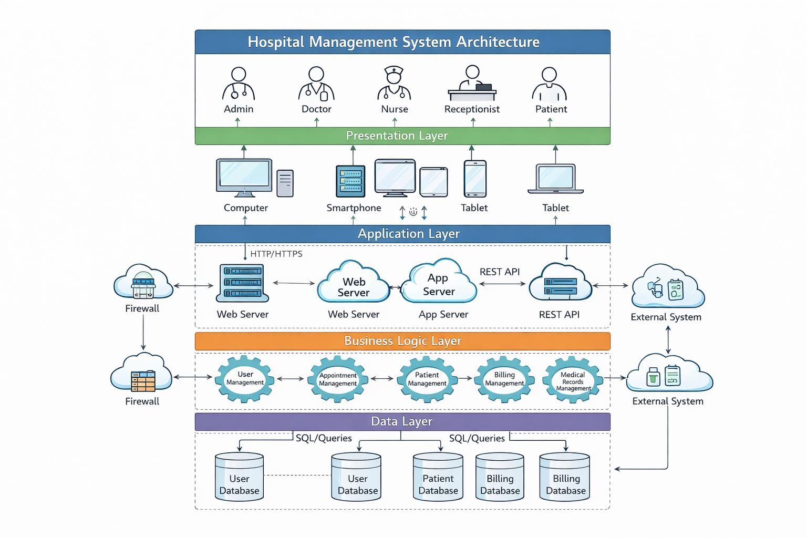
Fig 6.1: Hospital Management Sysytem Architecture

6.1 Data flow diagram

- The DFD is also called as bubble chart. It is a simple graphical formalism that can be used to represent a system in terms of input data to the system, various processing carried out on this data, and the output data is generated by this system.
- The data flow diagram (DFD) is one of the most important modeling tools. It is used to model the system components. These components are the system process, the data used by the process, an external entity that interacts with the system and the information flows in the system.
- DFD shows how the information moves through the system and how it is modified by a series of transformations. It is a graphical technique that depicts information flow and the transformations that are applied as data moves from input to output.
- DFD is also known as bubble chart. A DFD may be used to represent a system at any level of abstraction. DFD may be partitioned into levels that represent increasing information flow and functional detail.

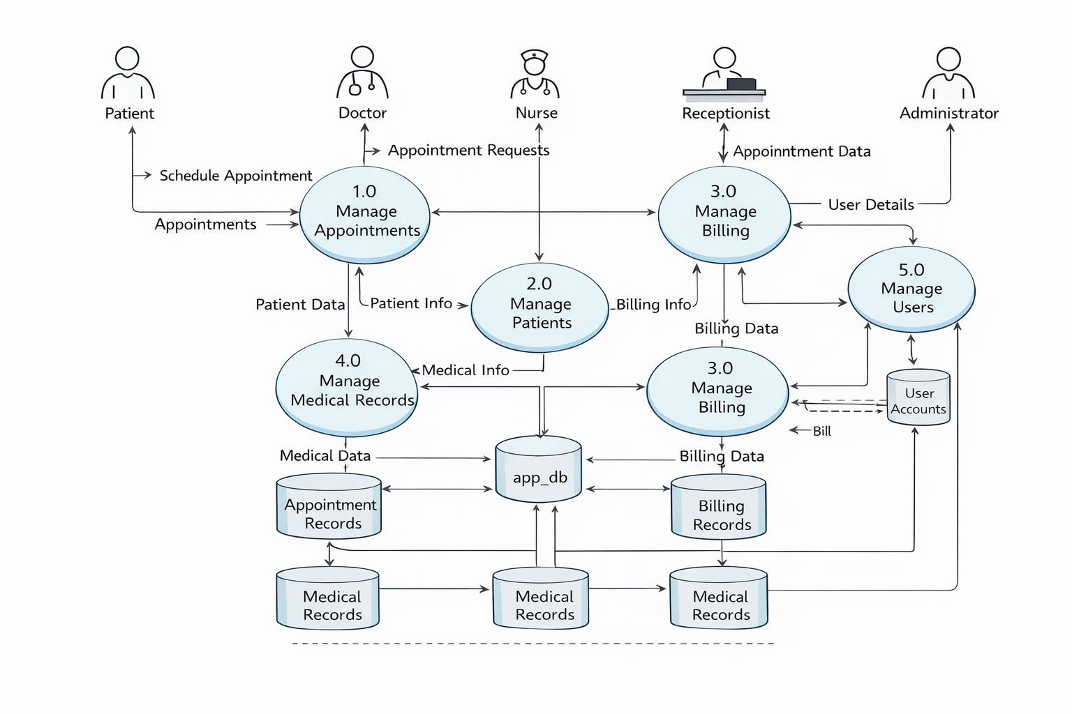
Fig 6.2: Data Flow diagram for the System

- UML diagrams

UML stands for Unified Modeling Language. UML is a standardized general-purpose modeling language in the field of object-oriented software engineering. The standard is managed, and was created by, the Object Management Group. The goal is for UML to become a common language for creating models of object oriented computer software. In its current form UML is comprised of two major components: a Meta-model and a notation. In the future, some form of method or process may also be added to; or associated with, UML.
The Unified Modeling Language is a standard language for specifying, Visualization, Constructing and documenting the artifacts of software system, as well as for business modeling and other non-software systems. The UML represents a collection of best engineering practices that have proven successful in the modeling of large and complex systems. The UML is a very important part of developing objects oriented software and the software development process. The UML uses mostly graphical notations to express the design of software projects.

- Goals

The Primary goals in the design of the UML are as follows:
- Provide users a ready-to-use, expressive visual modeling Language so that they can develop and exchange meaningful models.
- Provide extendibility and specialization mechanisms to extend the core concepts.
- Be independent of particular programming languages and development process.
- Provide a formal basis for understanding the modeling language.
- Encourage the growth of OO tools market.
- Support higher level development concepts such as collaborations, frameworks, patterns and components.
- Integrate best practices.

- Use case diagram

A Use Case Diagram represents the functional requirements of the Hospital Management System by identifying the different actors such as patient, doctor, admin, and staff. It shows how each actor interacts with the system through specific use cases like patient registration, appointment booking, consultation management, and billing. The diagram clearly defines the system boundaries and illustrates the relationships between actors and system functions. It helps in understanding user roles and responsibilities and ensures that all required functionalities of the system are properly identified and implemented.

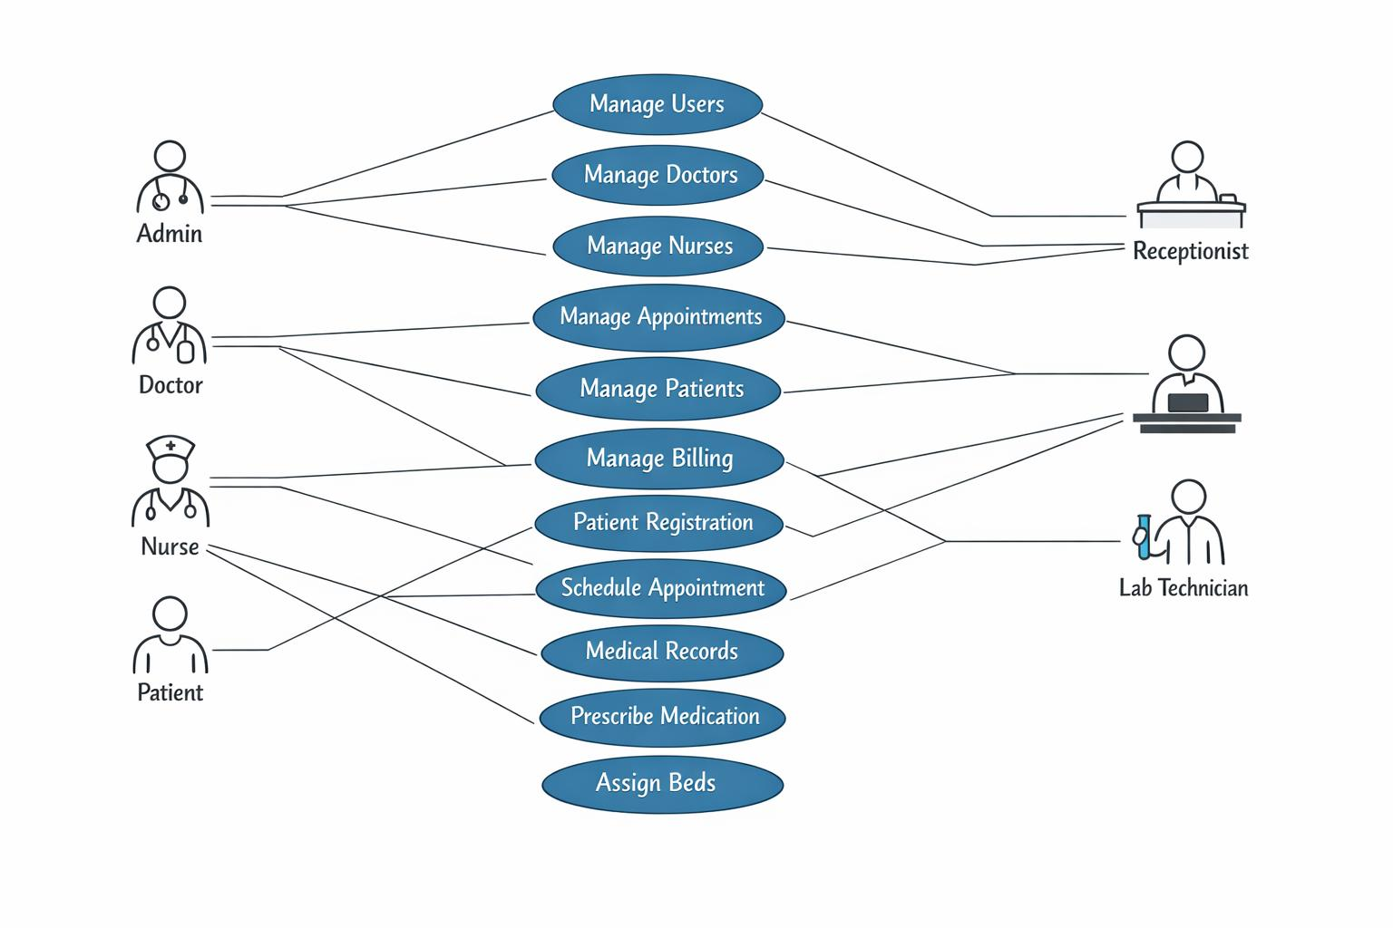

Fig 6.3: Use case Diagram

- Class diagram

A Class Diagram represents the static structure of the Hospital Management System by showing the main classes involved and their relationships. It includes classes such as Patient, Doctor, Appointment, Billing, and Admin, each containing attributes for data storage and methods for defining system behavior. The diagram illustrates how classes are connected through associations and dependencies, for example, a patient having multiple appointments or a doctor managing consultation schedules. It also defines access modifiers to ensure data security and proper control within the system. Overall, the class diagram acts as a blueprint for system development and helps developers understand the organization and structure of the application.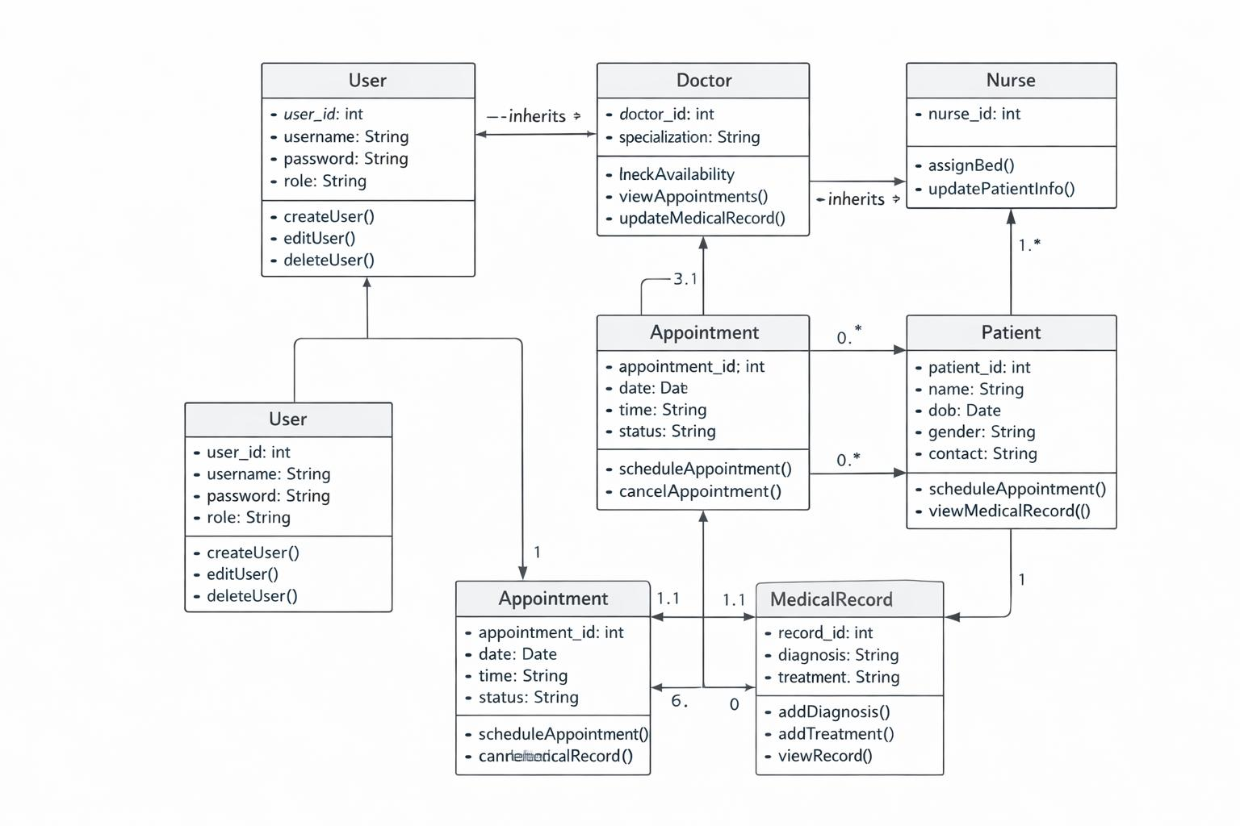
Fig 6.4: Class diagram

- Sequence diagram

The diagram follows a top-to-bottom flow, representing the sequence in which actions occur.
It begins with the patient initiating a request, such as appointment booking or registration.
The system processes the request and communicates with the database to store or retrieve information.
The doctor accesses patient details and updates medical records after consultation.
Billing details are generated based on services provided.
Confirmation messages are sent back to the user.
This diagram helps understand system behavior during execution.
It ensures proper coordination among system components.
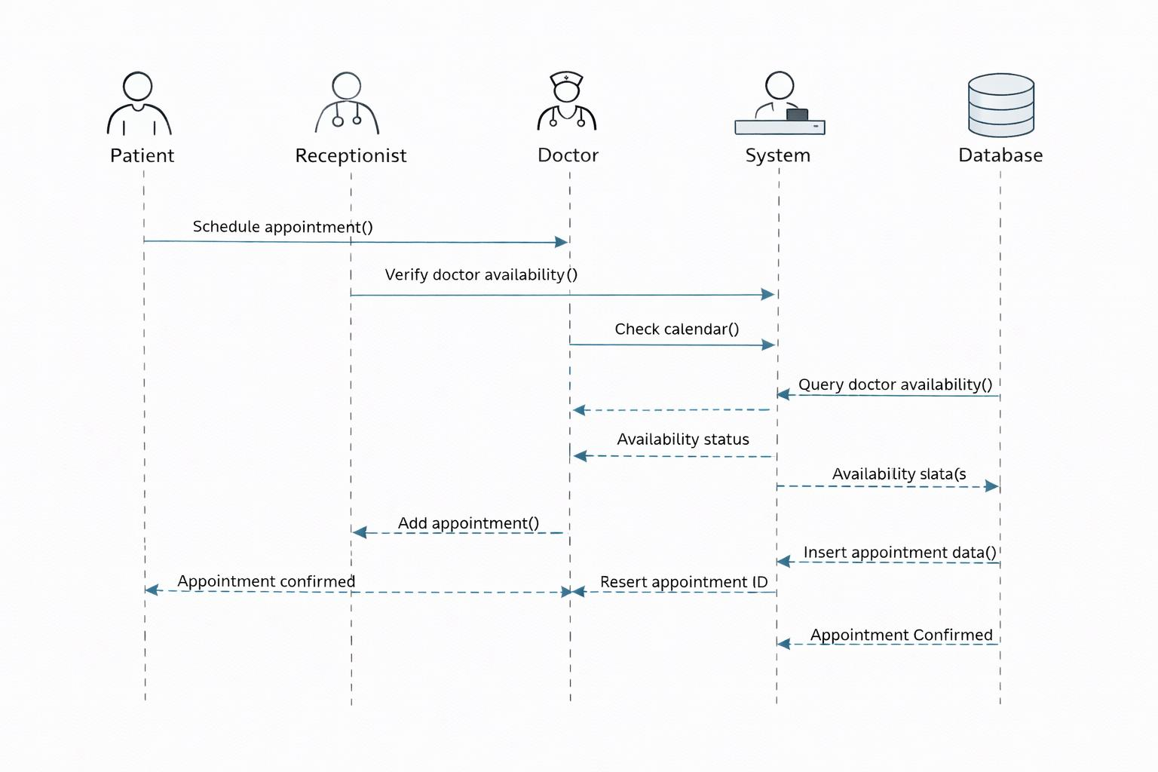
Fig 6.5: Sequence diagram

- Activity diagram
An Activity Diagram illustrates the workflow of activities involved in the Hospital Management System from start to end. It focuses on the sequence of actions performed and the decision points that control the flow of the system.
In the Hospital Management System, the activity diagram begins with patient entry into the system, followed by activities such as registration, appointment scheduling, consultation, and billing. Each activity represents a specific operation carried out by the system or hospital staff.

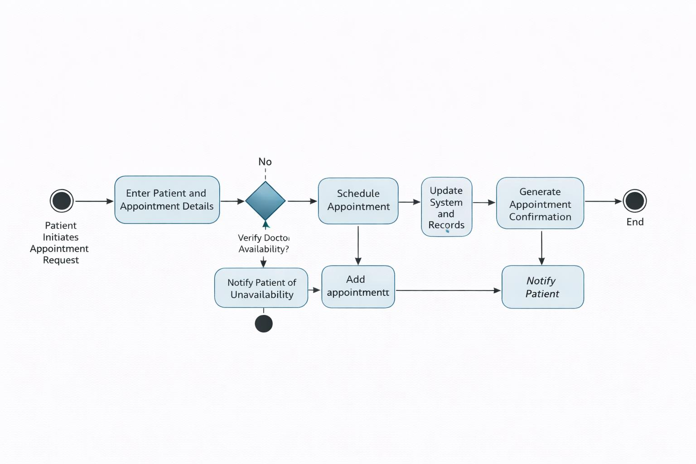
Fig 6.6: Activity Diagram

- Collaboration diagram
A Collaboration Diagram represents the structural organization of objects that participate in a specific interaction within the Hospital Management System. It emphasizes how objects are connected and how they work together to accomplish a particular functionality.
In this diagram, objects such as Patient, Reception, Doctor, Billing System, and Database are shown along with the links between them. The communication between these objects is represented using numbered messages, which indicate the order in which interactions occur.

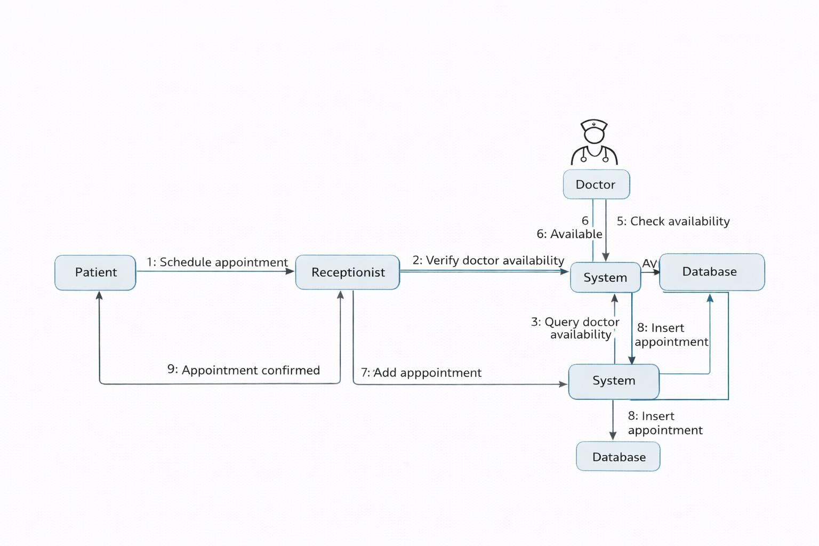

Fig 6.7: Collaboration diagram

SYSTEM SPECIFICATION
System specification describes the hardware, software, and execution environment required to develop and run the Hospital Management System efficiently.

7.1 Hardware requirements

The Hospital Management System can run on standard computer systems without the need for high-end hardware.
- Processor: Intel Core i3 or above
- RAM: Minimum 4 GB (8 GB recommended for smooth performance)
- Hard Disk: At least 20 GB free storage
- Display: 14-inch monitor or higher resolution
- Input Devices: Keyboard and Mouse
- Internet Connection: Required for system access and API communication
7.2 Software requirements

Operating System: Linux Distribution (e.g., Ubuntu, CentOS): Preferred for stability, security, and compatibility with machine learning frameworks and agricultural software.
Windows or macOS: Alternative operating systems for development and data analysis tasks.

Programming Languages
The following software tools and platforms are required for development and execution:
- Operating System: Windows 10 / Linux / macOS
- Frontend Technology: React.js
- Backend Technology: Java with Spring Boot
- Database: MySQL
- IDE / Editor: Visual Studio Code / IntelliJ IDEA
- Web Browser: Google Chrome / Microsoft Edge
- Package Manager: Node.js and npm
- API Testing Tool: Postman (optional)

EXECUTION FOR FRONT-END

The frontend of the Hospital Management System is developed using React.js. React provides a component-based structure that helps in building dynamic and responsive user interfaces for patients, doctors, and administrators.
Front-End Execution Process
Install Node.js and npm on the system.
Create a React application using the create-react-app command.
Develop components for patient registration, appointment booking, billing, and dashboards.
Connect frontend components with backend REST APIs.
Run the application using the development server.

Sample Front-End Execution Commands
npx create-react-app hospital-management
cd hospital-management
npm start
Sample React Code (Patient Registration Component)
import React, { useState } from "react";

function PatientRegistration() {
const [patient, setPatient] = useState({
name: "",
age: "",
contact: ""
});

const handleChange = (e) => {
setPatient({ ...patient, [e.target.name]: e.target.value });
};

const handleSubmit = (e) => {
e.preventDefault();
alert("Patient Registered Successfully");
};

return (
<div>
<h2>Patient Registration</h2>
<form onSubmit={handleSubmit}>
<input
type="text"
name="name"
placeholder="Patient Name"
onChange={handleChange}
required
/>
<input
type="number"
name="age"
placeholder="Age"
onChange={handleChange}
required
/>
<input
type="text"
name="contact"
placeholder="Contact Number"
onChange={handleChange}
required
/>
<button type="submit">Register</button>
</form>
</div>
);
}

export default PatientRegistration;

Front-End Execution Result
After successful execution, the application runs on the local server (default: http://localhost:3000).
Users can access different modules such as patient registration, appointment scheduling, and billing through a clean and responsive interface.

8 EXPERIMENTAL SETUP AND RESULTS

8.1 Experimental Setup
The experimental setup defines the platform and conditions used to evaluate the performance and correctness of the Hospital Management System.
- The system was installed on a personal computer with the required hardware and software configuration.
- The frontend was developed and executed using React.js in a local development environment.
- The backend services were run using Java Spring Boot with RESTful APIs.
- MySQL database was configured to store patient records, appointments, billing information, and staff data.
- The frontend and backend were connected using HTTP requests to ensure real-time data exchange.
- Different user roles such as patient, doctor, and admin were created to test role-based access.
- Sample data was inserted into the database to simulate real hospital operations.

8.2 Experimental Procedure
The system was tested by performing common hospital management activities step by step:
- Registering new patients and storing their details.
- Booking appointments based on doctor availability.
- Updating medical records after consultation.
- Generating bills for consultations and services.
- Processing payments and updating payment status.
- Managing doctor schedules and staff details through the admin module.
Each operation was verified for correct input handling, data storage, and output display.

8.3 Results and Observations
The following results were observed during system execution:
- Patient registration was completed successfully with unique patient identification.
- Appointment scheduling prevented overlapping time slots.
- Medical records were accurately stored and retrieved without data loss.
- Bills were generated automatically based on selected services.
- Payment status updates were reflected instantly in the system.
- Role-based access ensured secure handling of sensitive hospital data.
- The system responded quickly with minimal delay during normal usage.

8.4 Performance Evaluation
- The application performed efficiently with multiple users accessing the system.
- Data retrieval from the database was fast and accurate.
- The frontend interface remained responsive across different screen sizes.
- Error handling mechanisms worked correctly for invalid inputs.

8.5 Result Summary
The experimental results confirm that the Hospital Management System functions as expected. The system improves hospital workflow efficiency, reduces manual effort, minimizes errors, and ensures secure data management. The successful execution demonstrates the reliability and practicality of the implemented system.

CODING

Backend code

Main Application Class

package com.hms;

import org.springframework.boot.SpringApplication;

import org.springframework.boot.autoconfigure.SpringBootApplication;

@SpringBootApplication

public class HospitalManagementApplication {

public static void main(String[] args) {

SpringApplication.run(HospitalManagementApplication.class, args);

}

}

9.3 Entity Classes (Model Layer)

package com.hms.model;

import jakarta.persistence.*;

@Entity

public class Patient {

@Id

@GeneratedValue(strategy = GenerationType.IDENTITY)

private Long patientId;

private String name;

private int age;

private String gender;

private String contact;

// Getters and Setters

}

9.4 Doctor.java

package com.hms.model;

import jakarta.persistence.*;

@Entity

public class Doctor {

@Id

@GeneratedValue(strategy = GenerationType.IDENTITY)

private Long doctorId;

private String name;

private String specialization;

private String availability;

// Getters and Setters

}

9.5 Appointment.java

package com.hms.model;

import jakarta.persistence.*;

@Entity

public class Appointment {

@Id

@GeneratedValue(strategy = GenerationType.IDENTITY)

private Long appointmentId;

private String appointmentDate;

private String status;

@ManyToOne

private Patient patient;

@ManyToOne

private Doctor doctor;

// Getters and Setters

}

9.6 Repository Layer (Database Access)

package com.hms.repository;

import org.springframework.data.jpa.repository.JpaRepository;

import com.hms.model.Patient;

public interface PatientRepository extends JpaRepository<Patient, Long> {

}

9.7 DoctorRepository.java
package com.hms.repository;

import org.springframework.data.jpa.repository.JpaRepository;
import com.hms.model.Doctor;

public interface DoctorRepository extends JpaRepository<Doctor, Long> {
}
9.8 AppointmentRepository.java
package com.hms.repository;

import org.springframework.data.jpa.repository.JpaRepository;
import com.hms.model.Appointment;

public interface AppointmentRepository extends JpaRepository<Appointment, Long> {
}
Service Layer (Business Logic)
9.9 PatientService.java
package com.hms.service;

import java.util.List;
import org.springframework.beans.factory.annotation.Autowired;
import org.springframework.stereotype.Service;
import com.hms.model.Patient;
import com.hms.repository.PatientRepository;

@Service
public class PatientService {

@Autowired
private PatientRepository repository;

public Patient savePatient(Patient patient) {
return repository.save(patient);
}

public List<Patient> getAllPatients() {
return repository.findAll();
}
}
Controller Layer (REST APIs)
9.10 PatientController.java
package com.hms.controller;

import java.util.List;
import org.springframework.beans.factory.annotation.Autowired;
import org.springframework.web.bind.annotation.*;
import com.hms.model.Patient;
import com.hms.service.PatientService;

@RestController
@RequestMapping("/api/patients")
@CrossOrigin(origins = "http://localhost:3000")
public class PatientController {

@Autowired
private PatientService service;

@PostMapping
public Patient addPatient(@RequestBody Patient patient) {
return service.savePatient(patient);
}

@GetMapping
public List<Patient> getPatients() {
return service.getAllPatients();
}
}
application.properties
spring.datasource.url=jdbc:mysql://localhost:3306/hospital_db
spring.datasource.username=root
spring.datasource.password=yourpassword

spring.jpa.hibernate.ddl-auto=update
spring.jpa.show-sql=true
spring.jpa.properties.hibernate.dialect=org.hibernate.dialect.MySQLDialect

server.port=8080
MySQL Database Code
9.11 Create Database
CREATE DATABASE hospital_db;
USE hospital_db;
9.12 Patient Table
CREATE TABLE patient (
patient_id BIGINT AUTO_INCREMENT PRIMARY KEY,
name VARCHAR(100) NOT NULL,
age INT NOT NULL,
gender VARCHAR(10),
contact VARCHAR(15),
created_at TIMESTAMP DEFAULT CURRENT_TIMESTAMP
);
9.13 Doctor Table
CREATE TABLE doctor (
doctor_id BIGINT AUTO_INCREMENT PRIMARY KEY,
name VARCHAR(100) NOT NULL,
specialization VARCHAR(100),
availability VARCHAR(50)
);
9.14 Appointment Table
CREATE TABLE appointment (
appointment_id BIGINT AUTO_INCREMENT PRIMARY KEY,
appointment_date DATE NOT NULL,
status VARCHAR(30),

patient_id BIGINT,
doctor_id BIGINT,

CONSTRAINT fk_patient
FOREIGN KEY (patient_id)
REFERENCES patient(patient_id)
ON DELETE CASCADE,

CONSTRAINT fk_doctor
FOREIGN KEY (doctor_id)
REFERENCES doctor(doctor_id)
ON DELETE CASCADE
);
9.15 Billing Table
CREATE TABLE billing (
bill_id BIGINT AUTO_INCREMENT PRIMARY KEY,
patient_id BIGINT,
amount DECIMAL(10,2),
payment_status VARCHAR(30),
billing_date DATE,

CONSTRAINT fk_bill_patient
FOREIGN KEY (patient_id)
REFERENCES patient(patient_id)
ON DELETE CASCADE
);
9.16 Laboratory Table
CREATE TABLE laboratory (
lab_id BIGINT AUTO_INCREMENT PRIMARY KEY,
patient_id BIGINT,
test_name VARCHAR(100),
result VARCHAR(200),
test_date DATE,

CONSTRAINT fk_lab_patient
FOREIGN KEY (patient_id)
REFERENCES patient(patient_id)
ON DELETE CASCADE
);
9.17 Pharmacy Table
CREATE TABLE pharmacy (
medicine_id BIGINT AUTO_INCREMENT PRIMARY KEY,
medicine_name VARCHAR(100),
quantity INT,
price DECIMAL(10,2),
expiry_date DATE
);
9.18 Insert Sample Data (Optional)
INSERT INTO patient (name, age, gender, contact)
VALUES ('Ramesh Kumar', 35, 'Male', '9876543210');

INSERT INTO doctor (name, specialization, availability)
VALUES ('Dr. Anjali', 'Cardiology', 'Mon-Fri');

INSERT INTO appointment (appointment_date, status, patient_id, doctor_id)
VALUES ('2026-01-25', 'Confirmed', 1, 1);
9.19 Useful Queries for Demo
SELECT p.name AS Patient, d.name AS Doctor, a.appointment_date, a.status
FROM appointment a
JOIN patient p ON a.patient_id = p.patient_id
JOIN doctor d ON a.doctor_id = d.doctor_id;
9.20 Get Patient Bills
SELECT p.name, b.amount, b.payment_status
FROM billing b
JOIN patient p ON b.patient_id = p.patient_id;
- EXECUTION SCREENSHOTS
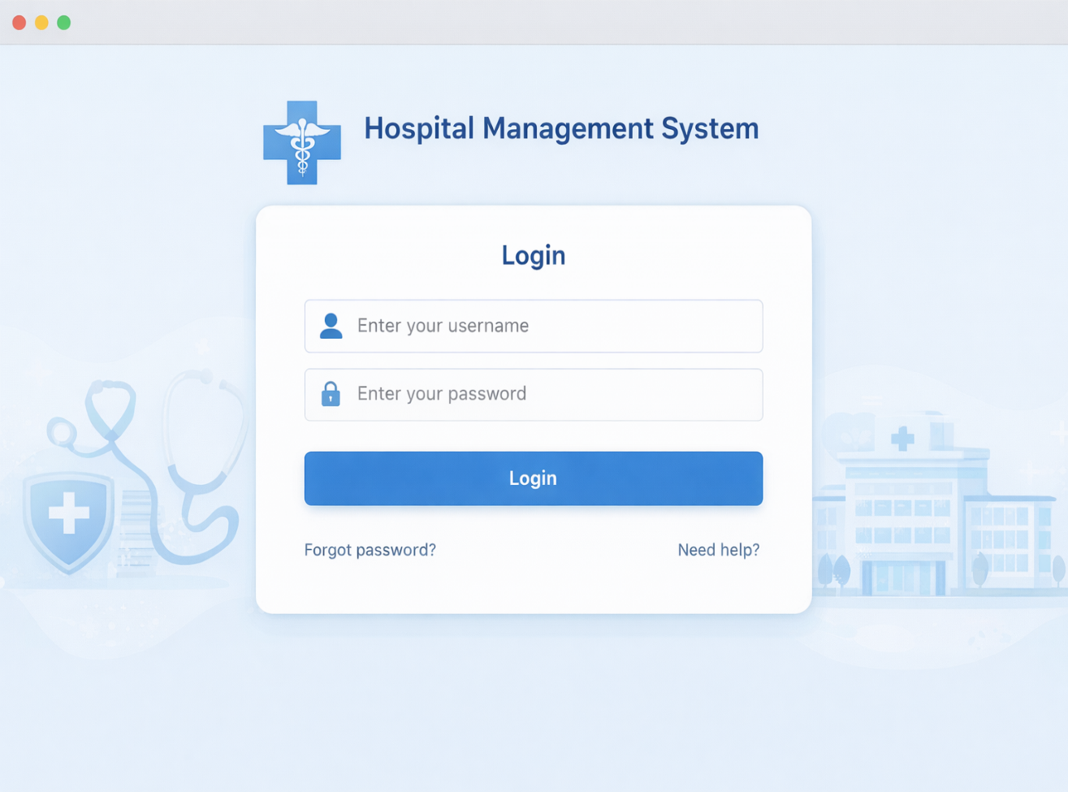

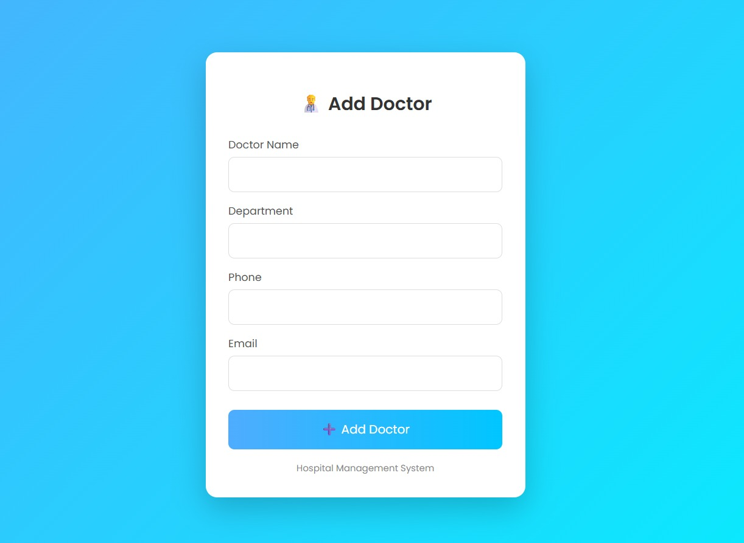

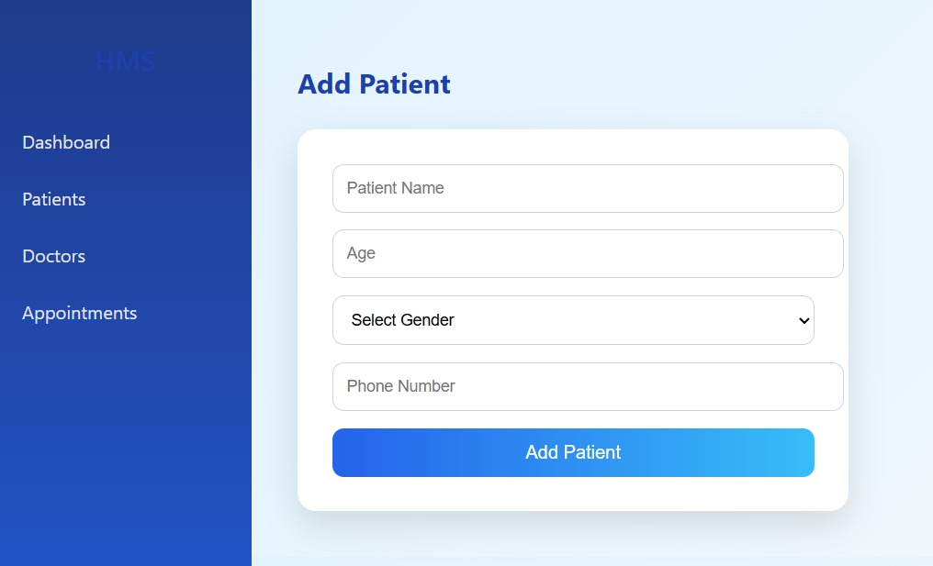

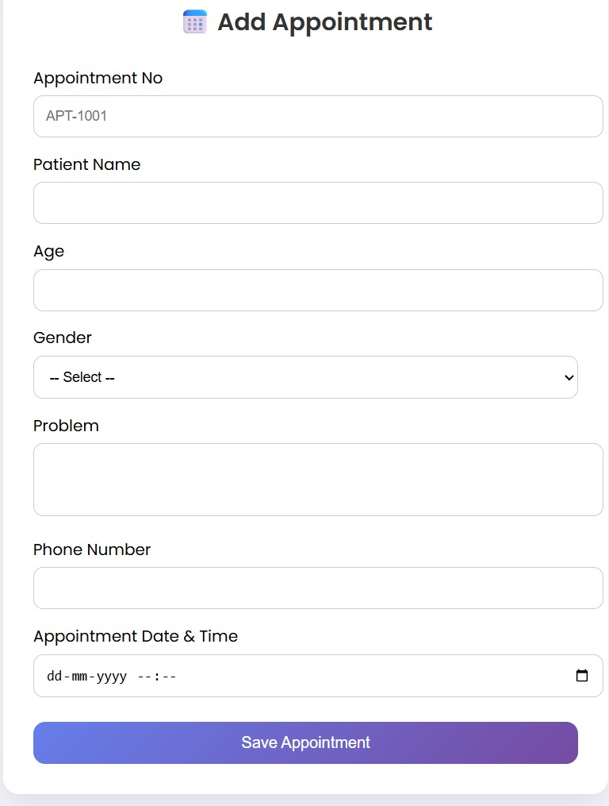

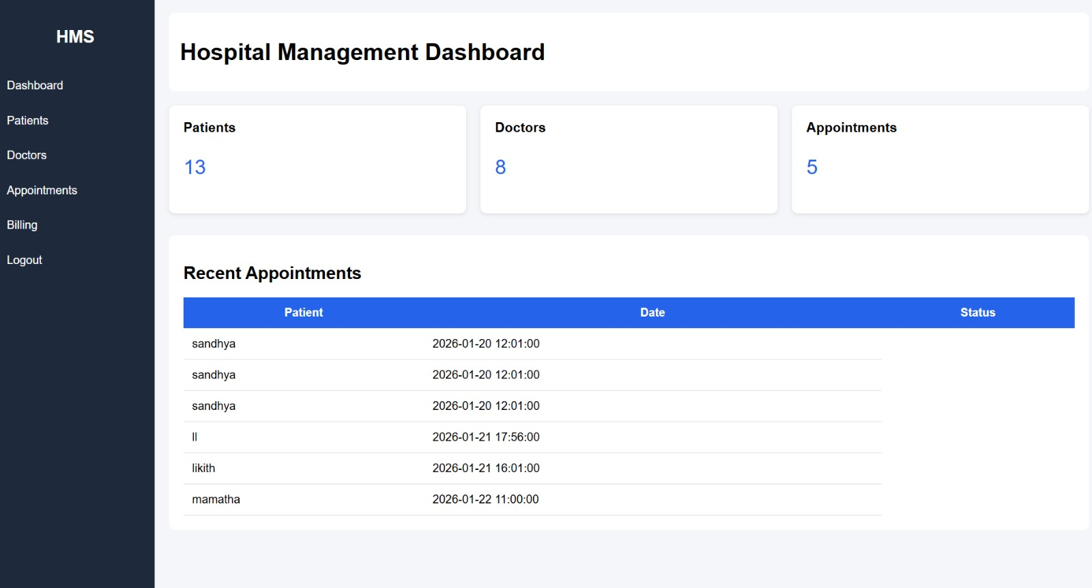

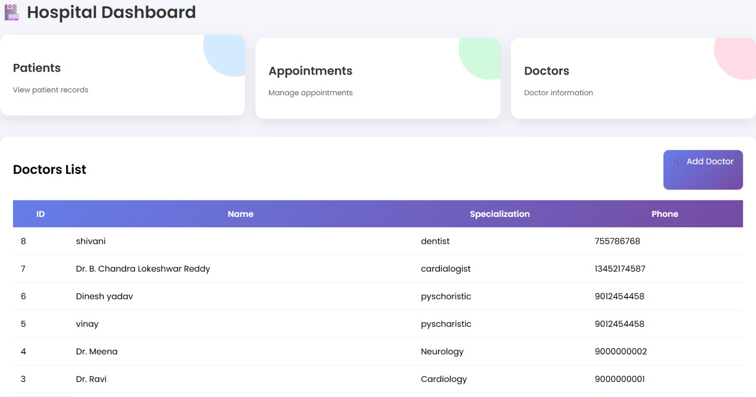

LIMITATIONS
Although the Hospital Management System improves hospital operations and data handling, it has certain limitations that should be considered.
- The system depends heavily on a stable internet connection; interruptions may affect real-time access and updates.
- Initial data entry requires manual effort, which may lead to errors if not properly verified.
- The system provides limited support for advanced medical decision-making and does not replace professional diagnosis.
- Integration with external systems such as insurance platforms and government health databases is restricted.
- Scalability may be limited when handling a very large number of users without additional infrastructure.
- Data security relies on proper configuration and user practices; misuse of credentials can compromise information.
- The system requires user training, and lack of technical familiarity may slow adoption among hospital staff.
These limitations highlight areas where future improvements and enhancements can be made.

FUTURE SCOPE

- The Hospital Management System has significant potential for expansion and improvement to support modern healthcare environments.
- Adoption of cloud-based deployment to improve system availability, scalability, and disaster recovery.
- Integration of electronic health record (EHR) standards to enable data sharing between different healthcare providers.
- Implementation of AI-powered chatbots to assist patients with appointment scheduling and basic inquiries.
- Development of decision-support systems to assist doctors with treatment planning and drug interaction alerts.
- Inclusion of automated resource management for beds, operation theaters, and medical equipment.
- Support for multi-language interfaces to improve accessibility for diverse users.
- Introduction of real-time reporting dashboards for hospital management to monitor performance metrics.
- These future enhancements will make the system more intelligent, scalable, and adaptable to evolving healthcare requirements.

- APPLICATIONS
The Hospital Management System (HMS) is widely used in real healthcare environments to streamline operations, improve patient care, and support administrative decision-making. Its applications extend across clinical, operational, and managerial domains, making it an essential component of modern hospitals and healthcare centers.

1. Patient Record Management in Hospitals
In real hospitals, maintaining physical patient files often leads to misplaced records and delayed treatments. The HMS replaces paper files with digital patient records. For example, in a multi-specialty hospital, a patient visiting different departments such as cardiology and orthopedics can have all medical history accessed instantly by doctors, enabling faster and more accurate diagnosis.

2. Appointment Scheduling in Outpatient Departments
Large hospitals face challenges in managing patient queues and doctor availability. The HMS appointment module allows patients to book appointments online and receive confirmation. For instance, in urban hospitals, patients can schedule consultations in advance, reducing overcrowding and waiting time at outpatient departments.

3. Clinical Workflow Support for Doctors and Nurses
Doctors and nursing staff use HMS to record consultations, update treatment plans, and monitor patient progress. In real-world usage, ward nurses update vital signs in the system, allowing doctors to review patient status remotely and make timely medical decisions.

4. Billing and Financial Operations
Hospitals handle complex billing involving consultations, diagnostics, pharmacy, and inpatient services. HMS automates billing by calculating charges based on services used. For example, during patient discharge, the system generates a consolidated bill, reducing disputes and improving payment accuracy.

5. Laboratory and Diagnostic Services
In diagnostic centers, test requests and result delivery must be fast and error-free. HMS allows doctors to order lab tests digitally and receive results directly in patient records. This reduces report delays and eliminates the risk of manual entry errors.

6. Pharmacy and Inventory Control
Real hospitals manage thousands of medicines daily. HMS tracks stock levels, expiry dates, and prescription dispensing. For example, hospital pharmacies use the system to get alerts when critical medicines are low, ensuring uninterrupted patient treatment.

7. Inpatient and Bed Management
Managing bed availability is critical in emergency and inpatient care. HMS provides real-time updates on bed occupancy. During high patient inflow situations, such as seasonal illness outbreaks, hospitals use HMS to allocate beds efficiently and avoid overcrowding.

8. Emergency Department Operations
In emergency units, time is crucial. HMS enables quick patient registration, immediate access to medical history, and fast coordination between departments. This helps emergency doctors provide rapid and informed treatment.

9. Administrative and Management Reporting
Hospital administrators use HMS-generated reports to analyze patient trends, revenue, and resource utilization. For example, management can identify peak admission times and adjust staffing accordingly, improving operational efficiency.

10. Data Security and Regulatory Compliance
Healthcare data is highly sensitive. HMS implements role-based access control and audit logs. In real-world scenarios, only authorized doctors can access patient records, ensuring privacy and compliance with healthcare regulations.

11. Multi-Department and Multi-Branch Coordination
Large healthcare groups operating multiple branches use HMS to centralize data across locations. For example, a patient visiting different branches of the same hospital chain can receive consistent care as their records are accessible system-wide.

Summary
In real healthcare environments, the Hospital Management System is applied as a centralized digital platform that enhances patient care, improves operational efficiency, reduces manual workload, and supports informed decision-making. Its wide range of applications makes it indispensable for hospitals, clinics, diagnostic centers, and healthcare networks.

14. SYSTEM TESTING

The purpose of testing is to discover errors. Testing is the process of trying to discover every conceivable fault or weakness in a work product. It provides a way to check the functionality of components, sub assemblies, assemblies and/or a finished product It is the process of exercising software with the intent of ensuring that the Software system meets its requirements and user expectations and does not fail in an unacceptable manner. There are various types of test. Each test type addresses a specific testing requirement.
13.1 TYPES OF TESTS
- Unit testing
Unit testing involves the design of test cases that validate that the internal program logic is functioning properly, and that program inputs produce valid outputs. All decision branches and internal code flow should be validated. It is the testing of individual software units of the application .it is done after the completion of an individual unit before integration. This is a structural testing, that relies on knowledge of its construction and is invasive. Unit tests perform basic tests at component level and test a specific business process, application, and/or system configuration. Unit tests ensure that each unique path of a business process performs accurately to the documented specifications and contains clearly defined inputs and expected results.
- Integration testing
Integration tests are designed to test integrated software components to determine if they actually run as one program. Testing is event driven and is more concerned with the basic outcome of screens or fields. Integration tests demonstrate that although the components were individually satisfaction, as shown by successfully unit testing, the combination of components is correct and consistent. Integration testing is specifically aimed at exposing the problems that arise from the combination of components.
- Functional test
Functional tests provide systematic demonstrations that functions tested are available as specified by the business and technical requirements, system documentation, and user manuals.
Functional testing is centered on the following items:
Valid Input : identified classes of valid input must be accepted.
Invalid Input : identified classes of invalid input must be rejected.
Functions : identified functions must be exercised.
Output : identified classes of application outputs must be exercised.
Systems/Procedures : interfacing systems or procedures must be invoked.
Organization and preparation of functional tests is focused on requirements, key functions, or special test cases. In addition, systematic coverage pertaining to identify Business process flows; data fields, predefined processes, and successive processes must be considered for testing. Before functional testing is complete, additional tests are identified and the effective value of current tests is determined.
4, System Test
System testing ensures that the entire integrated software system meets requirements. It tests a configuration to ensure known and predictable results. An example of system testing is the configuration oriented system integration test. System testing is based on process descriptions and flows, emphasizing pre-driven process links and integration points.
- White Box Testing
White Box Testing is a testing in which in which the software tester has knowledge of the inner workings, structure and language of the software, or at least its purpose. It is purpose. It is used to test areas that cannot be reached from a black box level.
- Black Box Testing
Black Box Testing is testing the software without any knowledge of the inner workings, structure or language of the module being tested. Black box tests, as most other kinds of tests, must be written from a definitive source document, such as specification or requirements document, such as specification or requirements document. It is a testing in which the software under test is treated, as a black box .you cannot “see” into it. The test provides inputs and responds to outputs without considering how the software works.
- Unit Testing
Unit testing is usually conducted as part of a combined code and unit test phase of the software lifecycle, although it is not uncommon for coding and unit testing to be conducted as two distinct phases.
Test strategy and approach Field testing will be performed manually and functional tests will be written in detail.
Test objectives
- All field entries must work properly.
- Pages must be activated from the identified link.
- The entry screen, messages and responses must not be delayed.
Features to be tested
- Verify that the entries are of the correct format
- No duplicate entries should be allowed
- All links should take the user to the correct page.
- Integration Testing
Software integration testing is the incremental integration testing of two or more integrated software components on a single platform to produce failures caused by interface defects.
The task of the integration test is to check that components or software applications, e.g. components in a software system or – one step up – software applications at the company level – interact without error.
Test Results: All the test cases mentioned above passed successfully. No defects encountered.
- Acceptance Testing
User Acceptance Testing is a critical phase of any project and requires significant participation by the end user. It also ensures that the system meets the functional requirements.
Test Results: All the test cases mentioned above passed successfully. No defects encountere

15 CONCLUSION
The Hospital Management System developed in this project provides a comprehensive and efficient solution for managing the complex operations of modern healthcare institutions. By integrating patient care processes with administrative and operational functions, the system successfully addresses the limitations of traditional manual record-keeping and fragmented hospital workflows.
The system enables accurate and centralized management of patient information, ensuring that medical records are securely stored and easily accessible whenever required. This improves continuity of care, supports timely clinical decisions, and reduces the risk of errors caused by missing or incomplete data. Digital record management also minimizes paperwork, saving time for healthcare professionals and allowing them to focus more on patient care.
Another major achievement of the system is the improvement in operational efficiency. Modules such as appointment scheduling, doctor management, billing, pharmacy, and laboratory services work together seamlessly. Automated scheduling reduces patient waiting times, while streamlined billing processes ensure transparency and faster financial transactions. These improvements contribute to better patient satisfaction and smoother hospital operations.
The Hospital Management System also enhances coordination among different departments. Real-time data sharing between doctors, nurses, laboratory staff, and administrative personnel ensures that all stakeholders have access to consistent and updated information. This level of integration supports effective teamwork and improves overall service quality within the hospital.
Security and data integrity are key strengths of the implemented system. Role-based access control restricts unauthorized access to sensitive patient information, ensuring confidentiality and compliance with healthcare data protection standards. The structured database design further ensures data accuracy, reliability, and long-term usability.
From a technological perspective, the system demonstrates the effective use of modern software development practices and tools. The combination of a user-friendly frontend, a robust backend, and a centralized database creates a scalable and maintainable architecture. The system is flexible enough to support future enhancements without major structural changes.
In conclusion, the Hospital Management System proves to be a reliable, practical, and valuable solution for healthcare organizations.

REFERENCES

• Pressman, R. S., Software Engineering: A Practitioner’s Approach, McGraw-Hill Education, 8th Edition.
• Sommerville, I., Software Engineering, Pearson Education, 10th Edition.
• Object Management Group (OMG), Unified Modeling Language (UML) Specification, OMG Publications.
• Oracle Corporation, Java Platform, Standard Edition Documentation, Oracle Docs.
• Pivotal Software, Spring Boot Reference Guide, Spring Official Documentation.
• Facebook Inc., React.js Official Documentation, https://react.dev
• Silberschatz, A., Korth, H. F., Sudarshan, S., Database System Concepts, McGraw-Hill, 6th Edition.
• MySQL AB, MySQL Reference Manual, Oracle Corporation.
• Fielding, R. T., Architectural Styles and the Design of Network-based Software Architectures, Doctoral Dissertation, University of California.
• ISO/IEC, Information Technology – Software Life Cycle Processes, ISO/IEC Standards.
• World Health Organization (WHO), Digital Health Systems and Hospital Information Systems, WHO Publications.
• IEEE Computer Society, IEEE Standards for Software Engineering Documentation, IEEE Press.
• Gamma, E., Helm, R., Johnson, R., Vlissides, J., Design Patterns: Elements of Reusable Object-Oriented Software, Addison-Wesley.
• Postman Inc., API Development and Testing Documentation, Postman Learning Center.
• National Institute of Standards and Technology (NIST), Guide to Data Security and Privacy in Healthcare Systems, NIST Publications.

IEEE FORMAT REFERENCES

- R. S. Pressman, Software Engineering: A Practitioner’s Approach, 8th ed. New York, USA: McGraw-Hill, 2015.
- I. Sommerville, Software Engineering, 10th ed. Boston, USA: Pearson, 2016.
- Object Management Group, Unified Modeling Language (UML) Specification, OMG, 2017.
- Oracle Corporation, Java Platform, Standard Edition Documentation. [Online]. Available: https://docs.oracle.com
- Pivotal Software, Spring Boot Reference Documentation. [Online]. Available: https://spring.io
- Meta Platforms Inc., React Documentation. [Online]. Available: https://react.dev
- A. Silberschatz, H. F. Korth, and S. Sudarshan, Database System Concepts, 6th ed. New York, USA: McGraw-Hill, 2011.
- Oracle Corporation, MySQL Reference Manual. [Online]. Available: https://dev.mysql.com
- R. T. Fielding, “Architectural styles and the design of network-based software architectures,” Ph.D. dissertation, Univ. of California, Irvine, 2000.
- IEEE Computer Society, IEEE Recommended Practice for Software Requirements Specifications, IEEE Std. 830.
- World Health Organization, Digital Health and Hospital Information Systems, WHO Press, 2020.
- National Institute of Standards and Technology, Security and Privacy Controls for Information Systems, NIST SP 800-53.
- E. Gamma et al., Design Patterns: Elements of Reusable Object-Oriented Software. Boston: Addison-Wesley, 1994.
- Postman Inc., API Development and Testing Guide. [Online]. Available: https://learning.postman.com
- ISO/IEC, Software Life Cycle Processes, ISO/IEC 12207

